Data Analytics

SQL Project1

-- create database

create database Project;

use Project;

SHOW VARIABLES LIKE "secure_file_priv";

create table olympics

(

ID int,

Name varchar (1000),

Sex char (20),

Age int,

Height int,

Weight int,

Team varchar (200),

NOC varchar(200),

Games varchar (200),

Year int,

Season varchar (200),

City varchar (200),

Sport varchar (200),

Event varchar (200),

Medal varchar (50)

);

load data infile 'C:/ProgramData/MySQL/MySQL Server 8.3/Uploads/Athletes_Cleaned.csv'

into table olympics

fields terminated by ','

enclosed by '"'

lines terminated by '\r\n'

ignore 1 rows;

select * from olympics;

-- 1. Show how many medal counts present for entire data

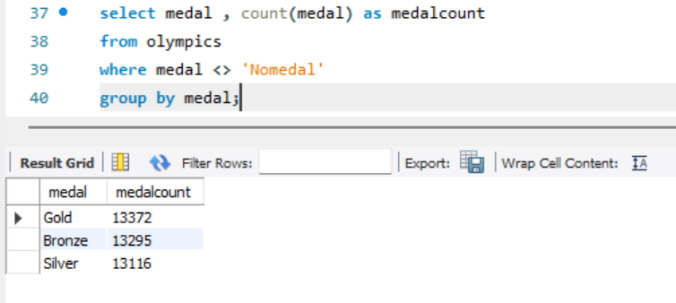

-- 2. Show count of unique sports present in Olympics1

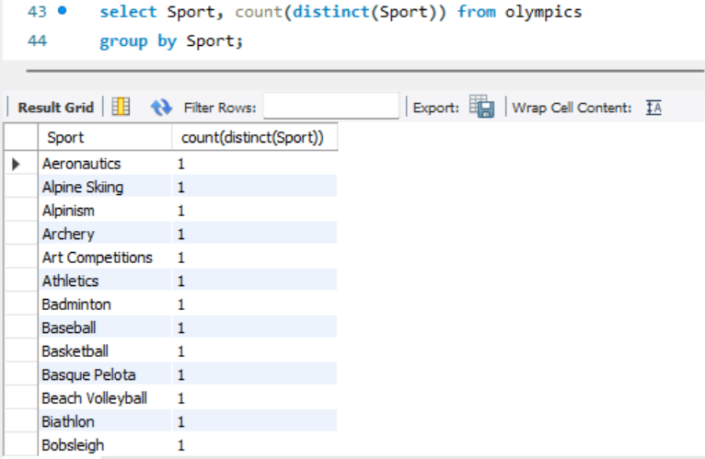

-- 3. Show how many different medals won by team India

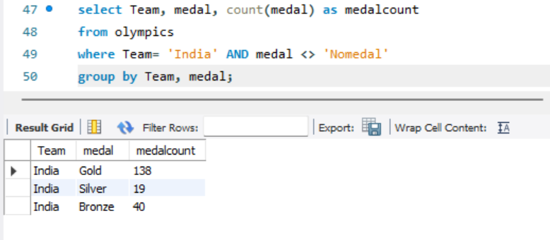

-- 4. Show event wise medals won by India show from highest to lowest medals won in order

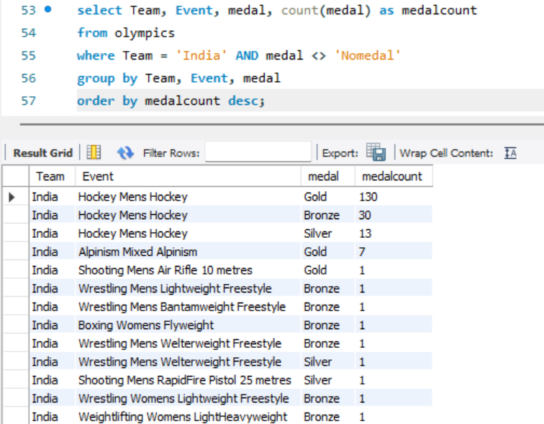

-- 5. Show event wise medals won by India in order of year

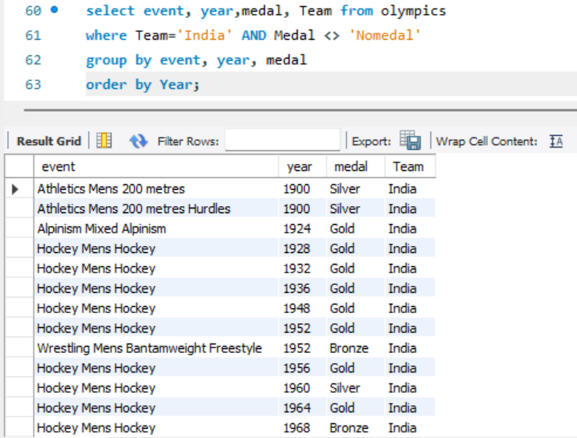

-- 6. show country who won maximum medals.

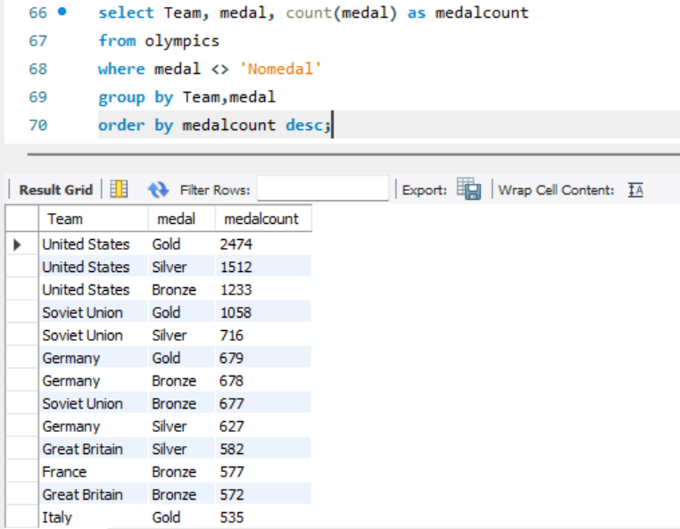

-- 7.show top 10 countries whowon gold

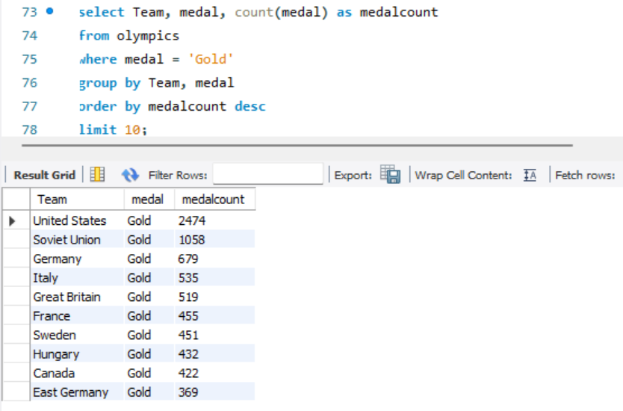

-- 8. show in which year did United states won most gold medal

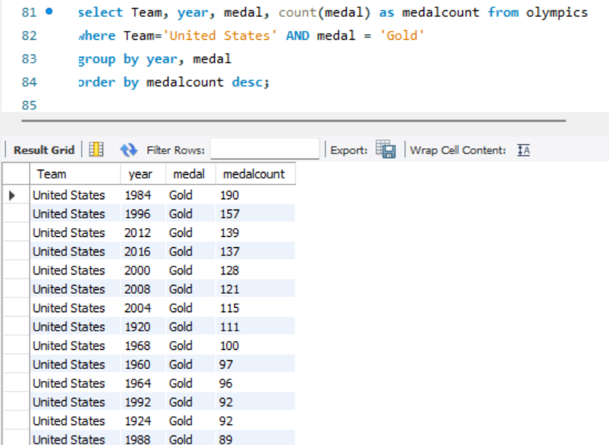

-- 9. In which sports United States has most medals.

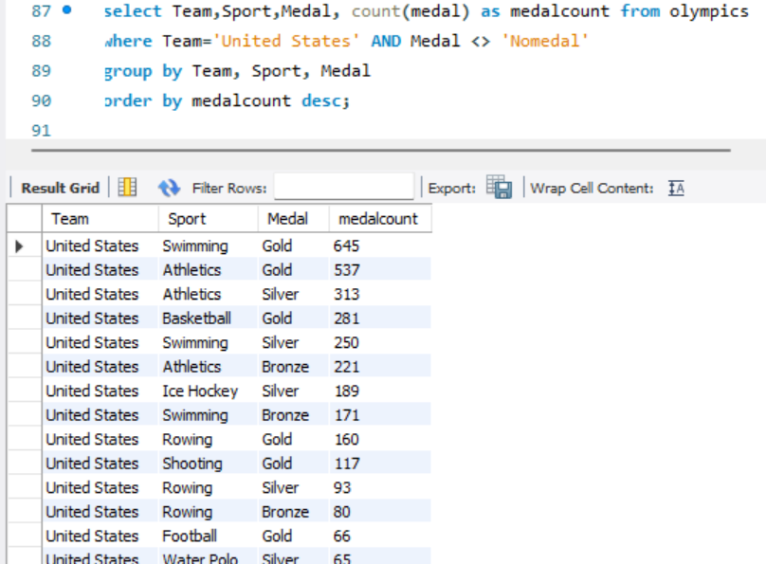

-- 10. Find top three players who won most medals along with their sports and country

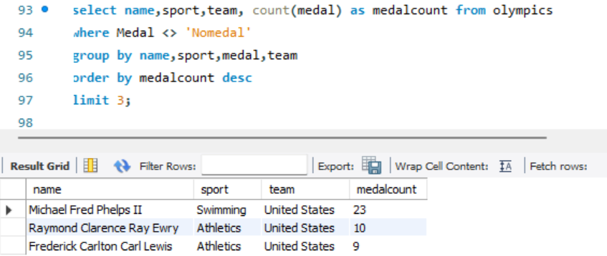

-- 11. Find player with most gold medals in cycling along with his country.

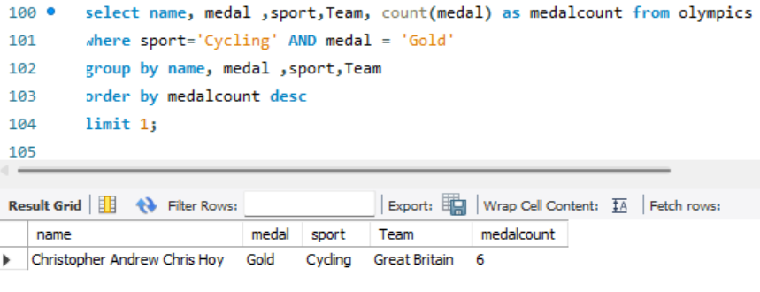

-- 12.Find player with most medals (Gold+Silver+Bronze) in Basketball also show his country.

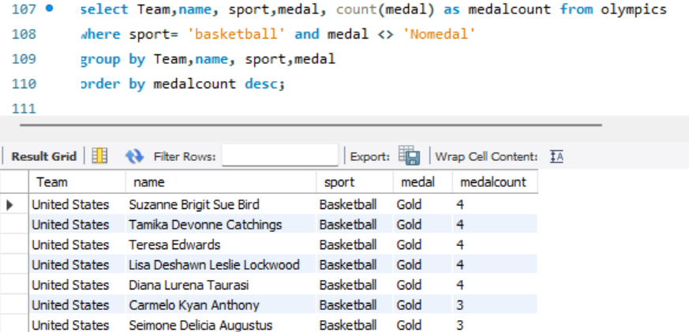

-- 13. Find out the count of different medals of the top basketball player Teresa Edwards

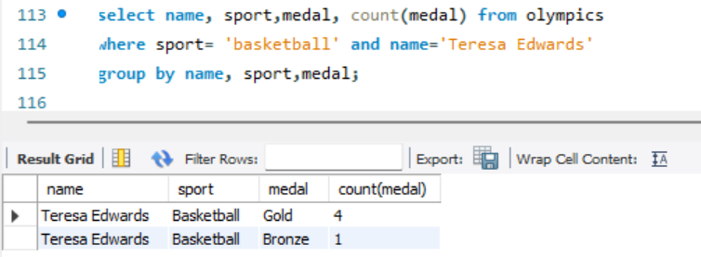

-- 14. Find out medals won by male,female each year , Export this data and plot graph in excel

